2017 West Virginia Historic Preservation Awards

Nomination Guidelines & Form

Preservation Alliance of West Virginia (PAWV) is accepting nominations for the 2017 West Virginia Historic Preservation Awards.

The 9th Annual Historic Preservation Awards Banquet will be on Saturday, September 30, 2017, at the Municipal Auditorium in Charleston.

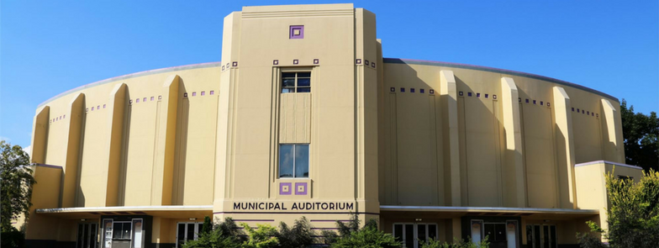

Guidelines:
- All nominations are due July 31, 2017 (Monday).
- Submit completed nomination form via email to info@pawv.org.
- Submit at least 3 photos - larger than 1 MB in size - of the project nomination with your nomination form.
A special nominating committee consisting of PAWV board members and staff will select and notify the awardees, as well as the nominators of the nomination status. All are welcome to submit nominations and attend the banquet. Nominators can submit more than one nomination but must submit one nomination per award. For information on award recipients from previous years, visit http://pawv.org/awards.htm.

Nomination Form:
- Select an Award Category for your nomination. Please choose one category per nomination.
(Indicate your choice by clicking the box or entering an X in front of the box.)
☐ Rodney Collins’ Preservation Achievement Award – A person or organization recognized for a recent and significant contribution to historic preservation in West Virginia.

☐ Heritage Tourism Award – A project, site, and/or organization recognized for having a significant contribution to the heritage tourism industry in West Virginia. These should be recent, innovative, and bring additional heritage tourists to West Virginia.

☐ Best Use of Historic Tax Credits Award – A project, organization, person, and/or company is recognized for the recent use of historic preservation tax credits to rehabilitate and re-use a historic building in West Virginia.

☐ Historic Landscape Restoration Award – A project, organization, person, and/or company recognized for the recent restoration of a historic landscape.

☐ Most Significant Save of an Endangered Property – This category is focused primarily on the West Virginia Endangered Properties List http://pawv.org/endanger.htm, however, if the property was not listed on the West Virginia Endangered Properties List, describe in the application how the property was formerly endangered and how it was saved. Also describe who saved the property and how it is being re-used.

☐ Award for Preservation of Historic Downtown Areas – Nominate a downtown-based organization, OnTRAC organization, Main Street community, or a local government for its recent preservation and re-use project(s) in historic downtown areas.

☐ Community Preservation Award – Nominate a person, organization, and/or company for its role in preserving and re-using multiple buildings in one community.

☐ Archaeology Award – Nominate a person, organization, and/or company for its role in preserving and re-using an archaeological site or for using archaeology in a historic preservation building project in West Virginia.

- Name/Organization/Project of Award Nominee:

- Project Name and Location:

- Nominee Contact Person:

- Nominee Address, City, State, Zip:

- Nominee Email:

- Describe why this project, person, organization, and and/or company is deserving of this award. Please include the start and finish dates of the projects, as well as project location, the names of all involved in the success of the project, and a description of the project.

- Nominator Name:

- Nominator Address, City, State, Zip:

- Nominator Email:

